

SIMATS ENGINEERING

Saveetha Institute of Medical and Technical Sciences
Chennai- 602105

Student Name: Deepan Kumar P Reg. No.:192312498
Course Code: CSA0202 Slot: C
Course Name: C programming Course Faculty: Dr.V.Jayasudha
Project Title: HOSPITAL PATIENT MONITORING SYSTEM
Module Photographs:
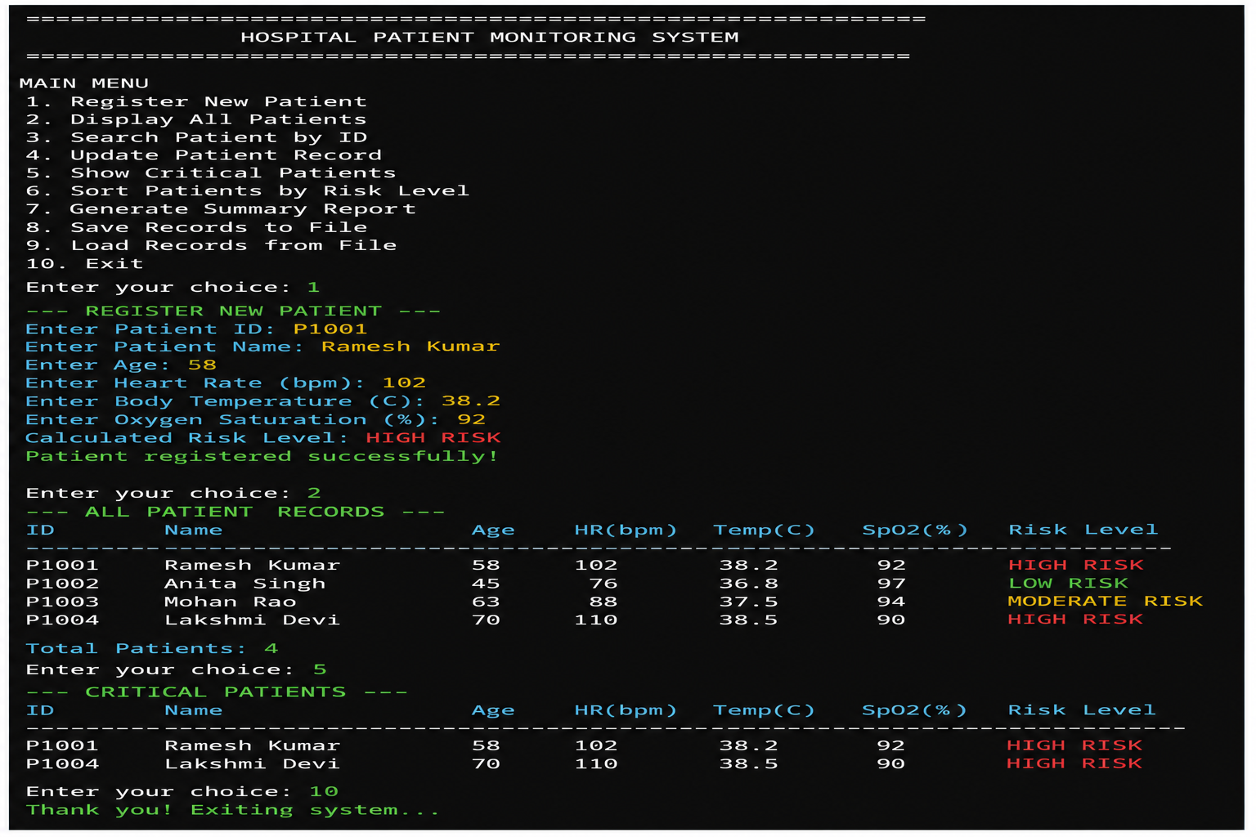
Project Description:

Module – Hospital Patient Monitoring System
The Hospital Patient Monitoring System is developed in C using a structure named Patient to store patient ID, patient name, age, heart rate, body temperature, oxygen saturation, and risk level. Functions using structure pointers are implemented to calculate and update the patient’s risk level based on the monitored vital signs. The system provides a menu-driven interface that allows the user to register a new patient, search for a patient using the patient ID, update vital signs, display patients requiring immediate attention, display all patient records, and exit the application. The risk level is classified as Low, Moderate, High, or Critical according to predefined conditions based on heart rate, temperature, and oxygen saturation. Input validation is used to prevent invalid physiological values and duplicate patient IDs, helping to maintain consistent patient records. The program demonstrates the practical application of structures, pointers, functions, arrays, loops, conditional statements, and menu-driven programming in C for a basic ICU patient monitoring system.

Deepan Kumar P
Student Signature Guide Signature

